MAp Exercises

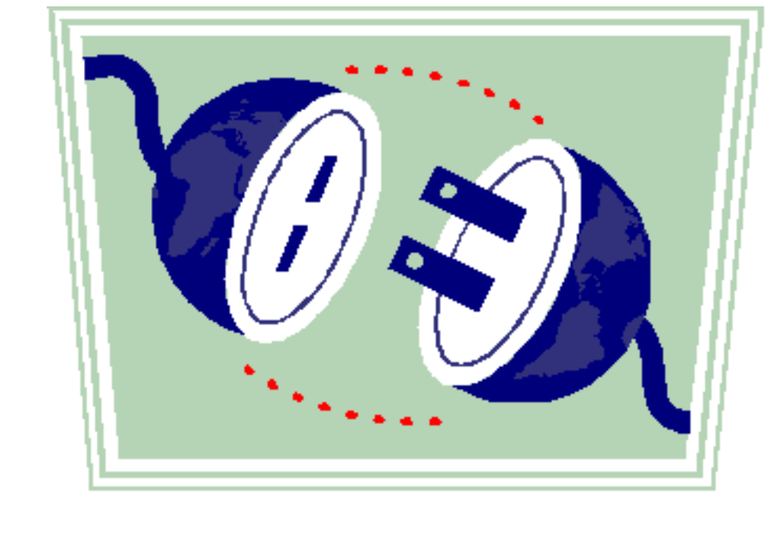

Notes for Exercises

- Some lab exercises may include an Instructor Example section, and a Lab section. The former is for the instructor to work through as an example, in part or in whole, with the students. The latter is for the students to work out in teams. For long exercises with multiple sections, the instructor might work out the instructor example just one section at a time, letting students work on the corresponding section of their student labs.

- The [estimated time], if any, for each lab student section, not including the time for the instructor to work out the instructor example section.

- Some labs have a starting template for the solution. Please begin that lab using that template. If solutions to the previous exercises are handed out, please use that solution as the starting point for the subsequent exercise so all teams work converging solutions.

- Work on the exercises in a team of 2-4 people. Don’t bunch all modelers into a single team. Work around one end of a table if possible. Work on a single solution using just one exercise workbook; you can make photocopies of your solution for the team at the end of each day.

- The purpose of many of these labs is to become familiar with the activities in MAp that you may perform or manage. These activities use models to produce clear descriptions with reduced ambiguities and errors. In some cases there will be many ways you can define the problem itself, or the solution to the problem. Remember that our main goal is to focus on the techniques, not the specifics of the example domain.

Exercise 1: Goals Vs. System Specs Vs. Internal Design [30 min]
Instructor: Exemplify each part of question with LCD-Projector example.
Students: Do corresponding part of exercise after the instructor example.
Apply MAP ideas to your use of a digital still camera for family vacation memories.
- What is your (external) goal that the camera helps meet? Try to step several levels further out than any preconceived interface of the digital camera itself. What objects in the world does that goal attempt to either observe or control? If you discover there are many levels of goals, you are right. But we won’t go into that just yet, so pick one.
Goal name: | Communicate visual material from laptop to audience
Description: | The laptop contains visual material about some topic. The audience has some level of understanding of that topic. The goal is to increase the audience level of understanding using the visual material on the laptop.
Observes: | - Laptop and visual material about some topic
Controls: | - Audience and its level of understanding of topic

- What properties of the external world objects are relevant to this goal e.g. distance, light, movement? List some state-related properties or attributes or relationships of at least 2 object types, and some events or behavioral properties. These may or may not be properties that are directly accessible to the camera. If these properties suggest some other goals, or obstacles to meeting goal, just note that down.
Object Type 1 | Laptop
Relevant State or Attributes | - Laptop must have visual material  - . | Suggested goals or obstacles  - .  - .
Relevant Behavior | - Laptops can switch between modes of projection: built-in screen, external projector, etc.  - . | Suggested goals or obstacles  - .  - .
Object Type 2 | Audience
Relevant State | - Knowledge or understanding of subject  - Can see  - can hear  - May be co-located or not  - May have other commitments | Suggested goals or obstacles  - .  - .  - Schedule meeting  - Arrange travel  - Allow distributed presentation  - Allow on-demand presentation
Relevant Behavior | - Need quiet for learning  - Can be distracted  - Can fall asleep | Suggested goals or obstacles  - .  - .
 | Projector
 | Light bulbs burn out

For parts 3-7 below you will fill in the table template provided.
- Can the digital camera alone meet the entire goal? What other solution components are needed to meet the entire goal? Which parts of the world does each component control? Observe? Sketch one or more diagrams showing how the components are connected, and label the lines with either the names of goal-related properties that are being communicated, or some related names. Show where your goal is located on this diagram.
Sketch of components
Component name | Controls:  - .  - .  Observes:  - .  - . | Black box properties:  - VGA → images  - Various switches … | White box properties:  - Lens  - Bulb  - …
Component name | Controls:  - .  - .  Observes:  - .  - . | Black box properties:  - Incoming image → reflected image  - ..size etc. | White box properties:  - .  - .
Component name | Controls:  - .  - .  Observes:  - .  - . | Black box properties:  - .  - . | White box properties:  - .  - .
Connector | Specification of connector in terms of its end-points.

- Show by argument or by walking through an end-to-end scenario on your sketch that these parts work together meet the goal.
- Write down 2-3 black-box specification properties (include at least one non-functional property) for the camera and for at least 1 other component. If a black-box itself permits other components to be plugged into it, would that be part of the black-box specification? If so, you can include those. Try to include those properties that are required by your scenario or correctness argument above.
Note the distinction and relationship between properties in the problem domain (e.g. distance, motion) and specifications of the camera (e.g. zoom, shutter speed).
- Based on your specification of the black-box components, discuss the role of, and specification for, the connection between those components. Can the overall assembly meet the goal if the connectors do not meet your connector specs?
- Write down 1 or 2 properties that are details of the camera internals that would not be externally visible, but that are constrained by the black-box properties you chose.
- Discuss each question and its significance within your team.

Exercise 2: The MAP Viewpoints and Process [20 min]
Instructor: Exemplify each part of question with LCD-Projector example.
Students: Do corresponding part of exercise after instructor example.

- Decide where your property descriptions from the previous exercise would be located on the MAP framework of viewpoints and concerns.
Viewpoint | Artifact | Concern: Functionality, Security, Location, Color, Weight, …
Business Architecture | Domain / Information Model:  Laptop.content  Audience.understanding  Goals:  Communicate laptop visual content to audience  Business Process:
Black Box Architecture | Assembly of connected black-boxes + human roles:  Presenter  Laptop (VGA cable)  Projector (photons)  Screen (photons)  Audience  Specification of individual black-box:  Projector:  - power  - switches  - (size, weight)  - VGA in → photons  Screen:  - reflection
White Box Architecture: | Internal structure of an individual black-box:  Projector:  - lens, signal proc, bulb, …

- Locate these properties on the slide showing the MAP template.
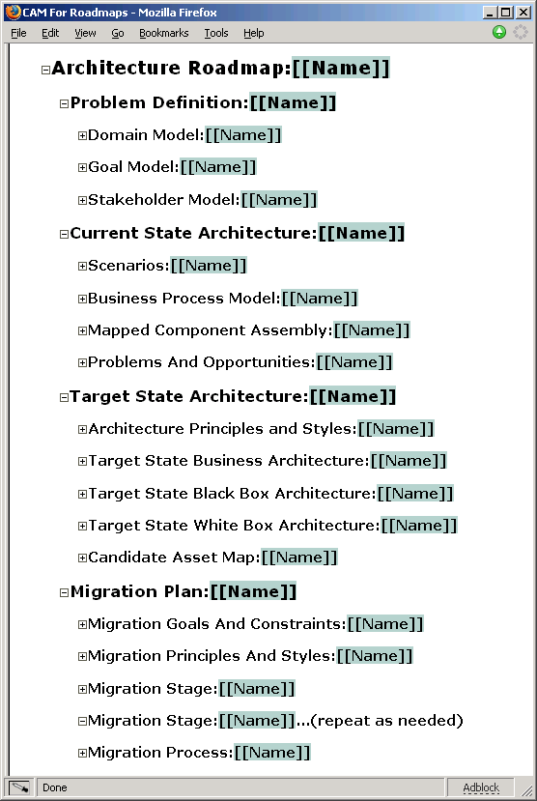

- Where in the slide showing the MAP process might you uncover each of these properties?
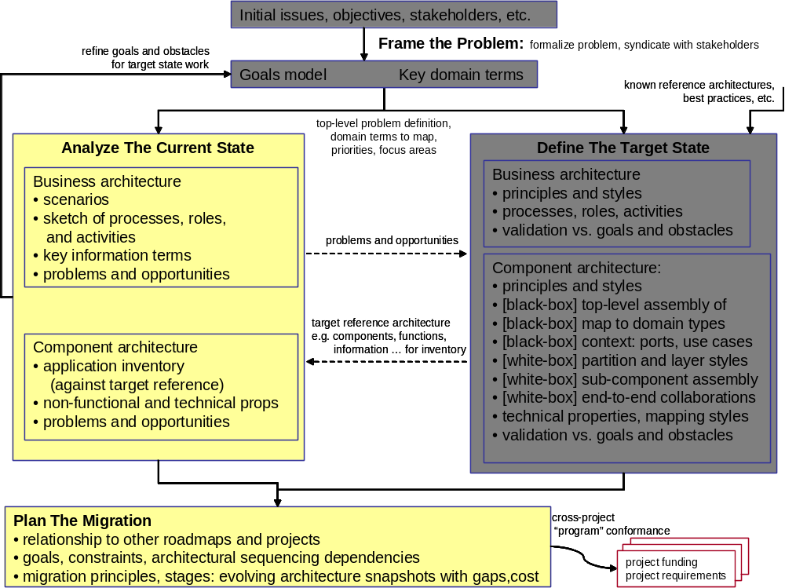

- Which of the properties might you consider critical ones that had better be uncovered and addressed early? Could you find any that could well have been left to a second iteration?

- Locate where you might capture these decisions about project management and prioritization on the MAP project management notebook template.

- If you see any interesting contrasts with how you might normally approach a project, discuss them with your team.

- Explore and discuss some additional goals, domain properties, solutions alternatives, or project management decisions and how they fit within the MAP framework.

Exercise 3
Instructor: Exemplify each part of question with LCD-Projector example.
Students: Do corresponding part of exercise after instructor example.

- List the top 3-5 goals of a security-related domain such as IDEM.

Goal | Definition

- List 2-5 types of objects in the domain that directly concern those goals, and the key attributes of those objects as mentioned in the goals.

Type | Definition
Attribute | definition
Type | Definition
Attribute | definition
Type | Definition
Attribute | definition
Type | Definition
Attribute | definition

- List 3-5 large-grained components that might be used to support that domain.

Component | Domain types, attributes, events etc. controlled | Observed

- Informally walk through a scenario that you believe exercises your domain. You can sketch out a collaboration diagram if needed.

Exercise 4
- Perform Why-How analysis of the goals for the security domain. Draw a goal model with between 4 and 6 goals in total. Check that you can objectively argue that subgoals do combine to properly meet the goal.
- Update your domain types and attributes to reflect the things referred to by the goals.
Type | Definition
Attribute | definition
Type | Definition
Attribute | definition
Type | Definition
Attribute | definition
Type | Definition
Attribute | definition

- Identify at least one obstacle to a goal, and a new goal to resolve that obstacle.

Exercise 5
- Select one goal from your security domain. Discuss all the triggers from the domain that might be relevant to that goal.
- Choose one trigger and walk through an end-to-end scenario to validate the goal is met.
- Your scenarios might reveal information about the component maps to the domain model. Update your component map to the domain model if needed.

Component | Domain types, attributes, events etc. controlled | Observed

